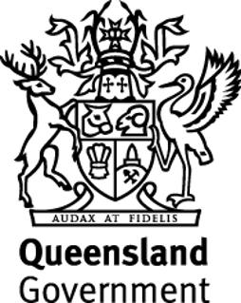
Regional Arts Development Fund
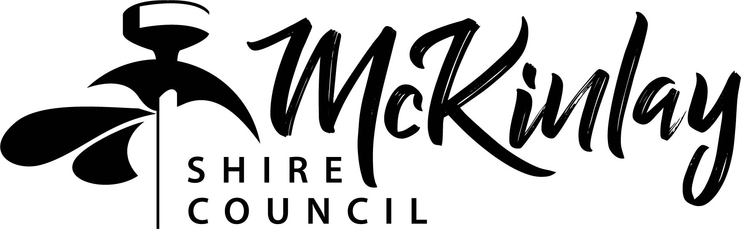

Program Guidelines
2019-20

About
The Regional Arts Development Fund (RADF) is a state and local government partnership that supports local artists and arts and cultural activities in Queensland communities.
For McKinlay Shire Council the Program makes arts and cultural activities more accessible for residents that otherwise wouldn’t occur due to distance from major centres.
RADF Funding Purpose
The Regional Arts Development Fund (RADF) is delivered as a partnership between the Queensland Government through Arts Queensland and eligible local councils across the State.
RADF promotes the role and values of arts, culture and heritage as key drivers of diverse and inclusive communities and strong regions. RADF invests in local arts and cultural priorities, as determined by local communities, across Queensland.
RADF is a flexible fund, enabling council to tailor RADF programs to suit the needs of their communities.
RADF aligns with Council’s Community Plan 2010-2020 that was developed following the most significant community consultation that Council has undertaken:
- Strategy 5 - Provide services and infrastructure that cater for all sections of the community, particularly young people and the elderly, that promote connection of people to community and each other;
- Strategy 7 - Develop and maintain a prosperous local economy supported by an increased population and new, sustainable and value adding industries;
- Strategy 10 - Establish and promote a thriving tourism industry;
- Strategy 14 - Plan and deliver sport and recreation, public space and community events;
- Strategy 25 - A Shire that prospers through partnerships and good governance.
- Actions:
- Explore opportunities to integrate culture and the arts into opportunities for tourism
- Continue to use successful governance models for key areas: Regional Arts Development Fund various arts related groups are members of the committee and have a say in the arts and cultural initiatives of the Shire.
- Develop capacity building programs to encourage local economic development and up‐skilling of the community, including our indigenous community.

RADF aligns with Council’s Corporate Plan 2016-2021 objectives:
Preserve and Maintain historic and culturally significant facilities and encourage cultural development through support of the Arts.
RADF Objectives
To support arts and cultural activities that:
  - Provide public value for Queensland communities
  - Build local cultural capacity, cultural innovation and community pride
  - Deliver the Queensland Government’s objectives for the community.
Key Performance Outcomes (KPOs)
Councils and funded activities will need to demonstrate how RADF investment is contributing to the following:
KPO | MEASURE
REACH
Local projects supported through RADF investment | Number of projects receiving RADF investment
Local communities engaged in RADF supported activities | Number participants and attendees at RADF supported activities
Diverse range of locals having a say in RADF related decision making | Number and diversity of community members engaged in decision making around RADF investment (reflective of local community demographic eg: young people and culturally diverse communities)
QUALITY
RADF projects deliver  on locally identified needs | RADF investment is directly linked to priorities identified in Council strategic plans and policies
Local communities value RADF | Attendees and participants rate RADF supported activities as good or excellent as evidenced through audience / participant / partner feedback
RADF contributes to liveability, community cohesion and local pride | Participants /attendees agree RADF supported activities make a positive contribution to local community  OR  Participants /attendees agree RADF supported activities build community pride/social cohesion as evidenced through audience / participant / partner feedback
VALUE
Local employment and/or professional development opportunities provided | Number of creatives employed or engaged in professional development as direct result of RADF investment
Local partners engaged in RADF supported activities | Number of new partners involved in RADF supported activities and projects
RADF leverages additional investment | $ value of investment towards RADF projects leveraged from other sources (e.g. earned income/sales revenue, private giving, sponsorship, other grant sources)
How RADF is Administered
Arts Queensland manages the RADF Program by means of an annual budget for allocations to individual Councils. Council has a nominated RADF Liaison Officer that provides administrative support to coordinate the Program and to provide a link between the community, the RADF Committee, Council and Arts Queensland. The RADF Committee is culturally and geographically representative of the community that meet to assess applications against guidelines set by Council.
Local Priorities
Public space activation
- for projects and activities that strengthen the connection between people and the places they share, paying particular attention to the physical, cultural, and social identities that define a place.
Youth Arts
- for projects and activities that support a wide variety of opportunities to explore and engage in the arts that aide and enhance the personal and social development of young people.

Professional development
- For local, individual professional artists and artsworkers to attend professional development seminars or activities; master classes; mentorships with recognised arts and cultural peers; and placements with recognised arts and cultural organisations.

- If an individual receives funding they will be required to contribute back to the community by way of volunteering to conduct free performances or teaching workshops locally. The hours of volunteering will be based on 5 hours per $500 dollars received.
Cultural tourism
- for projects and activities that focus on communities’ locally distinct arts, culture and heritage (including preservation) for both members of that community and for visitors.
Performances & exhibitions
- to facilitate performances and exhibitions open to the public to nurture creativity, inspire artistic vision and build a community with a passion for the arts.
Regional partnerships
- to encourage innovative and energising arts projects where artists, communities and councils work together in their community, or in partnership with another community, to achieve enhanced outcomes from RADF grants.
Workshops
- for community groups to engage a professional artist or artsworker to work with them on developing their arts practice or to run arts development workshops or community projects.
Artist in residence
- to invite arts and cultural workers into the community to provide these arts workers with the opportunity to build their portfolio and during their stay to engage and interact with the local community through presentations, workshops, or collaborating with local residents.
Health & wellbeing
- for projects and activities that improve the wellbeing of people who are experiencing health problems through active social engagement and creative outlets.

RADF Committee
The primary responsibilities of Committee members are to:
• promote the RADF program within the community;
• attend and participate in RADF meetings;
• assess RADF applications;
• ensure that funding allocated is in line with the RADF Principles, eligibility criteria, and Council’s cultural plans and policies;
• participate in RADF training;
• advise the RADF Liaison Officer, prior to the meeting, if they are unable to attend, ensuring that a quorum can be met.

All elected/selected members of a RADF Committee have full voting rights. RADF Liaison Officers provide administrative support to the committee, but have no voting rights. If the RADF Committee are unable to reach a majority decision, the Chair will have the casting vote.

Support for volunteers
Council will support RADF Committee members by providing support and reimbursement for reasonable expenses that include:
• out-of-pocket expenses
• petrol costs for those travelling long distances
• catering for meetings
• attendance of Committee members at public RADF events organised on behalf of council.
• social evenings
• dinners for Committee members at the end of the year
• providing access to training or mentoring activities.

Funding Rounds
Council will hold up to three funding rounds per financial year, and allow for quick response applications (where time frames are outside normal funding rounds), or until the budget is expended. Community Groups can submit multiple applications for funding in the same round or concurrent rounds. The RADF Committee assessment process can approve applications in principle, with Council to withhold payment of funds until relevant Outcome Reports are received.

Eligibility
• Individual professional artists, artsworkers, cultural workers or project coordinators who:
- are based in the local council area, or if based outside the local council area are able to demonstrate how the project will directly benefit arts and culture in the local council area
- have an Australian Business Number (ABN).
• Incorporated cultural organisations based in the local council area, or those based outside the local council area that are able to demonstrate how the project will directly benefit arts and culture in the local council area.
• Local Government’s and Local Government Committees for regionally beneficial projects.
• Travel and accommodation where reasonable
• Equipment and consumables where reasonable

Ineligibility
• Amateur arts activities except for professional services to amateur arts activity. Emerging professional artists are eligible for funding.
• Artists or artsworkers who do not have an Australian Business Number (ABN).
• Applicants who submit unsigned applications.
• Applicants who have failed to acquit previous RADF grants or other Council funding programs.
• Projects for which artsworkers are paid less than the recommended rates.
• Activities that commence before Council approval is given (retrospective costs).
• Framing or freight — only a small proportion of these costs can be covered as part of presentation costs for significant exhibitions.
• Entertainment — funding is not available to pay for entertainment for events, unless there is a developmental aspect included, e.g. musicians performing at a community event run a series of developmental workshops for community members prior to the event.
• Competitions - they are prolific and could monopolise funds. The competitive environment does not necessarily nurture emerging artists, as there is generally only one winner.
• Publishing costs - requests for grants to publish books should be directed to organisations that provide print-on-demand services. A small proportion of printing costs are eligible as part of the presentation costs for significant projects.
• Requests for prize money;
• Purchase of capital equipment – the purchase of office equipment such as computers,
printers, machinery, vehicles or capital equipment of any kind.
• Retrospective costs – projects/activities which have already taken place or began prior to
the application being lodged.
• Reimbursement of costs already incurred.

Assessment
When assessing applications for RADF grants the Committee is required to:
- align the project to local priorities;
- ensure eligibility criteria;
- judge applications on merit.
A concise rationale for funding decisions should be recorded as part of the minutes, so that applicants can be provided with feedback on their applications.

Changes to successful applications – must be approved by the RADF Liaison Officer in writing/email prior to commencement of the project/activity.

Outcome Reports
All RADF grant recipients must submit an outcome report no more than four weeks after the conclusion of their activity. This will include participant evaluation forms.

