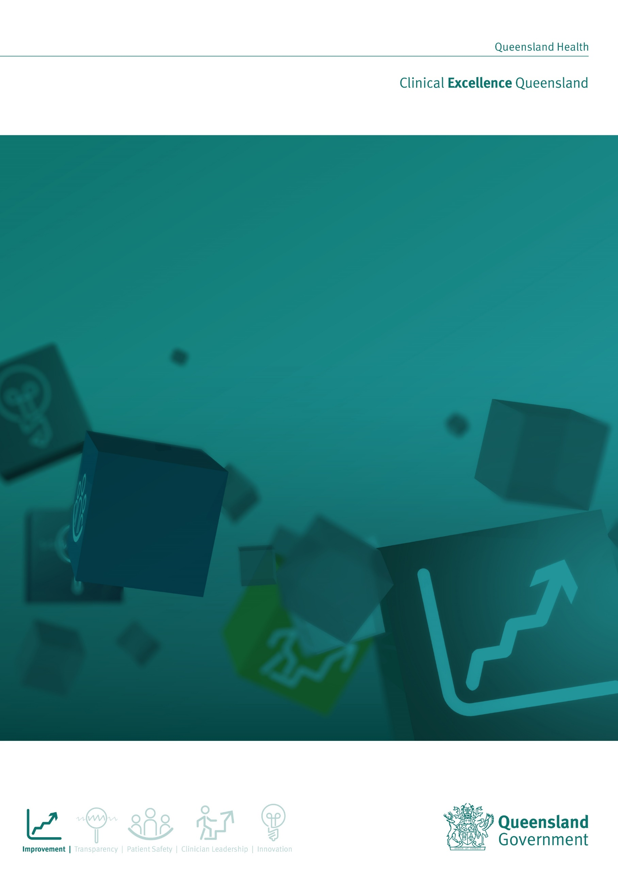

Tackling Regional Adversity through Integrated Care (TRAIC) Grants Information Pack

February 2019

Contents
A INFORMATION ABOUT THE TRAIC GRANT 3
1. Overview 3
2. Eligibility 4
3. Expression of interest process 6
B The Grant assessment Process 7
4. How applications are to be submitted 8
5. Questions 8
6. Contact details 8
7. Notification 8
8. Formation of a contract (for successful applicants) 9

ATTACHMENTS:

- Queensland Drought Situation Map

- Hospital and Health Services Map

- Previously Funded Grants

- Other Grants Funding

A INFORMATION ABOUT THE TRAIC GRANT

Overview
The Queensland Government supports rural and remote communities impacted by the drought, disaster and other crisis through an annual community grants program called the Tackling Regional Adversity through Integrated Care (TRAIC) Grants Program. For the 2019-2020 Grants round a locally led approach through co-design workshops is being undertaken. Co-design actively involves members of the community to help design more effective community-based programs. In this case, the programs would be in keeping with the TRAIC Grants funding conditions (page 4).

The workshops are being held in nine selected Queensland communities that have been impacted by adversity related to recent events: the drought, flooding, a disaster or other community crisis.

This approach ensures that community members and other stakeholders have an opportunity to provide input and help shape programs that would work best in building community resilience, increase mental health literacy and encourage help seeking behaviour. Local organisations attending the Grants Workshop who are eligible to apply for a TRAIC grant will be invited to submit an expression of interest. More details about this process are outlined in this document.

Background
As of October 2018, over 58.1% of Queensland is drought declared (a map of the affected areas is on page 10). In addition to the drought, Queensland communities have experienced adverse events including natural disasters such as flooding, cyclones and local community tragedies. More recently, the mining downturn has affected long-term job prospects.
Research has found that droughts and disasters negatively impact individual and community wellbeing, particularly in rural locations. Experiencing anxiety and loss are common initial responses to droughts and disasters. For some people, the longer-term effects include serious mental health conditions such as post-traumatic stress disorder and high levels of anxiety. Community resilience, in other words the community’s ability to utilise available resources to respond to, withstand and recover from adverse situations reduces the negative impacts of droughts and disasters.
The Tackling Regional Adversity through Integrated Care (TRAIC) program targets suicide prevention, building resilience and fostering recovery among people and communities affected by adversity.
The Program employs senior clinicians called Regional Adversity Integrated Care Clinicians (RAICCs) based in nine Hospital and Health Service (HHS) regions across rural, remote and regional Queensland and funding of $600,000 for the annual TRAIC community grants program.
In recognising the long-term impact of the drought, the Premier and Minister for Trade, Annastacia Palaszczuk, announced additional TRAIC program funding including $400,000 in 2018/19 and in 2019/20 for the TRAIC Grants Program to build community resilience in drought impacted communities. The total funding available for a community is $66,000 (excluding GST).

The TRAIC grants program
The purpose of the TRAIC grants program is to enable Queensland communities affected by adversity associated with drought, disaster and other crises to build community resilience. Community resilience is the sustained ability of a community to withstand and recover from adversity.
Community building strategies and projects include those that develop and promote community networks and support, provide information to improve mental health literacy and encourage and create opportunities for help seeking behaviour, particularly for people experiencing mental health issues, at risk of suicide or bereaved by suicide. Local government, non-government service providers and community groups or organisations may be eligible to apply for a TRAIC grant.
Queensland Health recognises that local solutions that draw on the expertise and lived experience of local people are more likely to be effective in addressing the challenges facing communities. A co-design approach avoids duplication of existing programs and strategies.

How the workshops will work

The mental health clinicians (RAICCs) in each region will work with community organisations, local councils and health staff to identify areas that are experiencing adversity. Once a location/s is selected, local stakeholders (with knowledge of issues that are affecting the community) will be invited to attend the workshops.

A facilitator from the Mental Health Alcohol and Other Drugs Branch will lead each workshop. Each participant will receive a workshop report (by email) that outlines all decisions and recommendations made during the workshop.

Before each workshop, participants will be asked to commit to genuine principles of equality and collaboration.

The workshop content:
- An outline TRAIC Grants scope, eligibility and timeframes;
- The facilitator will ask participants to share their views on the impact of the drought;
- All participants will be asked to identify themes;
- Themes will be prioritised;
- Participants will be asked to identify programs to support the community to build resilience;
- The group will make recommendations and reach a final decision – and nominate an organisation to manage or auspice the funding;
- All participants will receive a workshop report and the nominated organisation/s will be invited to apply for a TRAIC Grant.

Eligibility for grants
Project terms are for no longer than one-year and all projects must be completed by 30 June 2020. Funding up to a maximum of $66,000 (excluding GST) is available to undertake community resilience building strategies, projects and activities. Two projects for different initiatives up to the value of $66,000 can be accepted. The funding amounts indicated are GST exclusive.
- Funding may be used for
The scope of eligible projects may include:
- Events that promote community connectedness; provide skills training on resilience building, mental health or suicide such as workshops or other forms of community gathering;
- Projects that promote communities working together to achieve a common goal in building resilience;
- Resources to upskill workers, volunteers, clients, carers and families about ways to improve mental health and wellbeing, identify and appropriately respond to people experiencing mental health issues or those at risk of suicide or bereaved by suicide;
- Development of resources to meet the needs of the community including resources for Culturally and Linguistically Diverse and Aboriginal and Torres Strait Islander people;
- Projects that improve help seeking behaviour.

- Funding may not be used for
Applications for grant funding that include any of the following will not be considered:
- Projects for communities in Queensland that are not targeting drought or disaster (or community crisis) affected communities in a Health and Hospital region, see page 11;
- Projects that do not focus on community resilience building strategies, projects and activities;
- Recurring maintenance or operational costs of existing programs or facilities;
- Interstate or overseas travel;
- Applications to subsidise the cost of owning or operating a property in a drought or disaster affected community. For example, subsidies for electricity, transporting water or livestock;
- Projects requiring or likely to require recurrent funding;
- Activities to collect funds for redistribution;
- Projects that duplicate an existing or similar project or service within the community (see page 13-15 for projects that have previously received a TRAIC Grant);
- Retrospective projects;
- Projects which are considered high risk or contravene relevant legislation, codes of conduct, (e.g. National Code of Conduct for Health Care workers (Queensland)) Queensland Health’s vision, strategic plans (https://www.health.qld.gov.au/system-governance/strategic-direction/plans) policies or policy intent (https://www.health.qld.gov.au/system-governance/policies-standards).

- Which organisations are eligible?
Only a legal entity and Local Government Authorities may be funded. If your organisation is unincorporated and you would like to apply for funding you may approach an incorporated organisation to auspice your project.
Funding is available to assist community sector (not-for-profit) organisations, non-government organisations and local government authorities to undertake community resilience building strategies, projects and activities.
Organisations must be:
- a legal entity at the time of lodging the application or have proof of an auspice arrangement with an incorporated organisation. The contract will be between the department and the legal entity.
- Able to deliver the project in a drought or disaster affected area/s of Queensland within one of the HHS regions.
Please note legal entities are permitted to sponsor multiple organisations in this grant round.
You can check your organisation’s status and eligibility at www.abr.business.gov.au and www.connectonline.asic.gov.au.

- Who cannot apply
Funding is not available to:
- State or Australian Government agencies;
- Private or commercial enterprises registered under company law;
- Individuals;
- Organisations with an overdue acquittal obligation from a previous TRAIC grant. However, if an organisation has received a TRAIC grant for a project that has not yet been completed, it is eligible to apply for another project.
- Funding available
The funding is exclusive of GST. Refer to Section 8 GST of the Social Services (Short Form) Terms and Conditions for details.
Maximum funding amount: $66,000 (excluding GST)
Successful applicants are required to expend all funds by 30 June 2020.

Application process
Participants attending each workshop will be asked to nominate an organisation that has the capacity to deliver the project. Note that a local organisation (that meets eligibility criteria) can apply for funding for an initiative delivered by an external agency with the skills and proven ability to deliver the initiative (see table on pages 12-13 for examples of previously funded programs).
3.1 Closing date and time
Applications can be lodged within two-three weeks of each workshop. Successful applicants will be notified in writing by July 2019.

B The Grant assessment Process
Stage 1: Mandatory eligibility requirements
All applications will first be considered against the mandatory eligibility requirements for both the organisation and the project. Applicants considered ineligible will not proceed to the next stage.
Organisations will be advised in writing if their application is considered ineligible and the reason for that decision.
Mandatory eligibility requirements are listed below:
- Provision of the details of the contact person for communication regarding the application.
- The application has been made by an eligible organisation at the time of lodgement (Refer to Section A, 2.3).
- The project targets the identified issue (at the community workshops) related to drought, disaster, recent event, or other community crisis the eligible regions.
- Insurance and Indemnity as specified in the Social Services (Short Form) Terms and Conditions are required to be funded by the Department of Health. Evidence is required that the organisation has the relevant insurance for the project. If the organisation does not meet this requirement an explanation is required in the application response.
Stage 2: Assessment and recommendations
Applications determined to be compliant with eligibility requirements are assessed against the following criteria:
- Identified community need for the project that was reported at the at TRAIC Co-Deign Workshop and outlined in the Workshop Report.
- The project outcomes, activities and strategies are consistent with those defined during the workshop and outlined in the Workshop Report.
- There was consensus at each community workshop that the initiative would be a viable way to build community resilience and address adversity.
- Demonstrated ability to engage with and build community capacity to improve resiliency and help-seeking behaviour, as an example “Evaluation of a training package delivered to ten local residents found that it improved knowledge and confidence to identify and respond to people experiencing mental health issues and resulted in increased referrals to the local counsellor”.
- Organisational capacity and capability to deliver the project, as an example there is a low risk of the project not being completed.
- Value for money, as an example the requested funding and overall cost of the project, is relative to the anticipated benefits of the project for the community.
The below table outlines how applications are assessed.
Assessment Criteria | Sub-sections for evaluation | Evaluator comments
Consistency with the project meeting the needs identified in the workshop | - Does the project describe the target group, geographic location of the community, and need for the project?  - Does the project plan detail project tasks, milestones, timelines, risks and risk management?
Does the project plan describe how the program objectives will be met | - Describe how the project will address any of the following TRAIC objectives identified in each workshop, for example:  - Promote community resilience  - Develop and promote community networks and support  - Provide information to improve mental health literacy  - Encourage and create opportunities for help seeking behaviour
Consistency with priorities outlined in the grant workshop report | - Does the application describe the issues and priorities that are to be addressed?  - Does the project describe how the activities will address the issues/priorities to be addressed
Assess the organisational capacity and capability to deliver the proposed strategy, project or activity. | - Demonstrate the organisation’s capacity and capability (such as qualifications and experience) to develop, deliver, manage and monitor the project objectives in the specified community and/or the specified target group.

Stage 3: Approvals
Approval is based on recommendations made during the TRAIC Grants workshops and against mandatory grant criteria. Representatives from the Department of Health and Hospital and Health Service will assess projects.
It cannot be guaranteed that all successful projects will receive the amount requested. The decision is final and Queensland Health reserves the right to not provide funding at its discretion.

How applications are to be submitted
  - Registration
All applicants must email applications to traic@health.qld.gov.au
- Questions
Any questions by applicants related to the Grant application process must be communicated online to the Department of Health to traic@health.qld.gov.au .

Contact details
Contact | traic@health.qld.gov.au
- Notification
Following the evaluation of all grant applications and approval by the Department of Health each applicant will be advised in writing of the outcome of their application.
If your application is successful you will be provided with the details necessary to finalise your service agreement.
Unsuccessful applicants are encouraged to request feedback on their application within the timeframe specified in their notification letter.
- Formation of a contract (for successful applicants)
The Agreement will comprise:
- Short Form – Terms and Conditions; and
- The Particulars.
The applicant must have the ability to accept and comply with the terms and conditions of the Agreement and to deliver the Services as agreed under those terms and conditions.
The Service Agreement will be subject to the (Short Form) Terms and Conditions version 1.2. The terms and conditions can be viewed at www.hpw.qld.gov.au/SiteCollectionDocuments/UpdatedShortFormtermsandconditions.pdf.

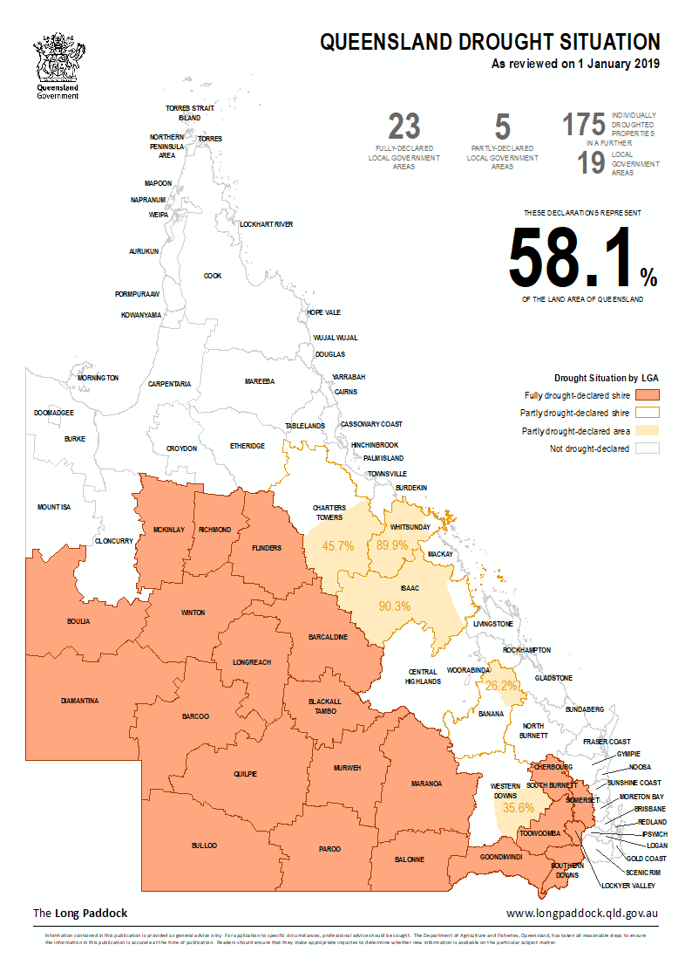

HHS | Applicant | Project Name | Project
Cairns and Hinterland | Agforce Queensland Farmers Limited | Our Agribusiness Expos - strengthening communities through education and support | Three ‘marquee’ events will be delivered in Malanda, Mareeba and Mount Surprise. The project aims to improve mental health literacy through the delivery of targeted education sessions and the presence of support services providing information on how to seek help.
Central Queensland | Central Queensland Rural Division of General Practice Assn Inc | Enabling and Enhancing Community Wellbeing in the Banana Shire | The project will deliver train-the-trainer suicide prevention workshops, enhancing community resilience around suicide prevention and increasing mental health literacy. The aim is to build resilient communities that can recognise when mental health problems develop and be able to seek help when needed.
 | Central Queensland Regional Council | Providing Counselling By Chance and Let's Talk Suicide | The project will deliver education sessions in Capella, Gemfields, and Tieri and focus on youth in Blackwater and Emerald. Participants will increase their understanding of mental health issues and learn the basic skills to support someone in an emotional crisis or at risk of suicide by learning how to recognise, respond and refer to an appropriate service for assistance.
Wide Bay | North Burnett Regional Council | Reconnecting Communities | The project will provide a series of comedy events across communities that have been impacted by the culminative effects of both drought and flooding. The events provide an opportunity to openly discuss mental health issues and share concerns about issues impacting on the community.
 | Uniting Care Community | Project Seahorse, Riding the waves of life, resiliently | Coordinated by the Discovery Coast Wellness Group, the project aims to address stigma around mental illness through different strategies including a film project and promotion of an easily recognisable emblem to break down mental health communication barriers.
Central West | Red Ridge (Interior Queensland) Ltd | Dress the Central West | The project will deliver regional showcase events, including creative skills based workshops, focused on improving mental health and wellbeing. Workshop participants will be provided information about mental health and encouraging help-seeking behaviour.
Townsville | Prospect Community Services | Building Connected Communities | This project allows for selected communities to have champions trained to deliver suicide prevention awareness training. Local 'mental health' champions in the Cardwell, Home Hill, Charters Towers, Burdekin, Ayr, Hughenden and Richmond areas will promote positive messages about mental wellness and encourage people to seek help when needed.
Darling Downs HHS | Agforce Queensland Farmers Limited | Darling Downs Wellbeing Project | The project will focus on events that raise awareness, educate and support regional communities about the importance of good mental health, under the guise of entertainment. Entertainment events will take in a number of drought affected communities including Chinchilla, Stanthorpe and Kingaroy.
North West HHS | McKinlay Shire Council | Celebrating our Volunteers | The project will build the capacity of volunteers to help reinvigorate much needed social events and activities in the community. The project culminates in a two-day whole of community event that will focus on building connectedness to improve the wellbeing of the community.
 | Cloncurry Shire Council | Cloncurry Community Wellness Project | The project will include three community driven projects with the aim to encourage people to seek positive help prior to mental health conditions going from manageable to crisis. The projects aim to address social isolation, lack of access to services and mental health information.
Mackay HHS | Girudala Community Co-operative Society Ltd | Whitsunday Opening Doors | The project will implement community mental health ‘heroes’ modelling help-seeking behaviour with the aim to address lack of knowledge about the early signs of distress and mental health stigma.
 | Emergency and Long-Term Accommodation Inc | Stronger Smarter Communities | The project will promote a “grass roots” approach to early suicide prevention by connecting with people when they start to become vulnerable. The group work collaboratively in the community to deliver multiple programs to increase mental health literacy and promote help-seeking behaviours.
South West HHS | Murweh Shire Council | Murweh Shire Community Drought Strategic Projects Group | The Murweh Community Drought Strategic Project will deliver a program of community workshops and a major event in drought affected communities in Augathella, Morven, Charleville and Cooladdi to improve mental health literacy and information on accessing mental health services.

Other grants funding available:
- The Queensland Mental Health Commission
- There are a number of Queensland Government grants available including the Community benefit fund for grants from $500 to $35,000 through the Gambling Community Benefit Fund (GCBF). This fund is Queensland’s largest one-off grants program, distributing approximately $53 million per year to Queensland communities.
- There is also funding for community-led projects delivered across Queensland, bringing together local communities to celebrate and share what they love about Queensland. More information on these grants and other avenues to apply for grant funding can be found at the Queensland Government grants website at: https://www.qld.gov.au/community/community-organisations-volunteering/funding-grants-resources

- The Queensland Government Grants Finder website can be located at the link below; https://www.grants.services.qld.gov.au/#/

Drought Assistance Schemes

- The Drought Relief Assistance Scheme (DRAS) is offered by the Queensland Government and administered by the Department of Agriculture and Fisheries (DAF). https://www.business.qld.gov.au/industries/farms-fishing-forestry/agriculture/rural-disaster-recovery/drought/assistance/dras-subsidies

- The Queensland Government and Australian Government offer programs to help farm families, farm businesses and farm communities affected by drought. This page provides broad descriptions of government drought assistance programs available to Queensland producers. https://www.daf.qld.gov.au/business-priorities/agriculture/disaster-recovery/drought/assistance-programs

- The Department of Communities, Disability Services and Seniors is responsible for administering $4.0 million of the Community Drought Support Package on behalf of the Department of Agriculture and Fisheries. Funding is provided over a 12 month calendar period. Funding allocations are weighted on the basis of the Department of Agriculture and Fisheries’ drought declared regions, population levels, demographic measures and regional intelligence. Funding eligibility requires LGAs to be fully or partially drought declared, or to include Individually Droughted Properties, as October 2018

