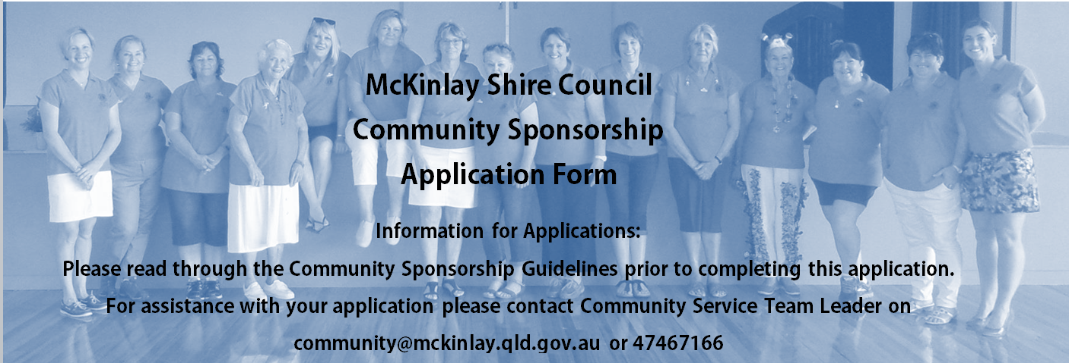

1. ORGANISATION/GROUP DETAILS
Name: ___________________________________________________________________________
Contact Person: ____________________________ Position: _______________________________
Postal Address: ____________________________________________________________________
Ph: _________________________________ Mobile ______________________________________
Email: ____________________________________________________________________________
What is your organisations/groups primary purpose? ______________________________________
__________________________________________________________________________________________________________________________________________________________________
Organisation’s ABN: ____________________________________
Is your Organisation registered for GST? Yes No
Did your organisation/group receive Sponsorship last year from Council?
Yes No - Amount received $ _________________
Did your organisation/group receive in-kind support last year from Council? Yes No
Does your organisation have public liability insurance?
Yes – please attach copy of certificate No

2. PROJECT INFORMATION
A) Project/Event name: _____________________________________________________________
B) Date of proposed project/event ____________________________________________________
C) Project/Event description:
______________________________________________________________________________________________________________________________________________________________________________________________________________________________________________________________________________________________________________________________________________________________________________________________________________________________________________________________________________________________________
D) Estimated total attendance? _________________
E) Target audience: U/18 19-30 31-40 41-50 60+
F) Type of project/event (tick all that apply):
Education Entertainment Arts / Culture Community
Sports Charity Environment Business
G) Provide an estimate of how many volunteers will be involved in the project/event. ___________
H) How will the project/event benefit McKinlay Shire residents and have a positive impact on the community?___________________________________________________________________________________________________________________________________________________________________________________________________________________________________________________________________________________________________________________________________________________________________________________________________________

I) Will the project/event be open to all residents, or members only? _________________________

J) What type of Sponsorship are you seeking?
Cash: Amount requested - $_____________
Fee waiver: Hire of Council venue - ________________________________________________
Hire of tables and chairs
Other _____________________________________________________________ _____________________________________________________________________
K) What will the Sponsorship funds be used for?
_________________________________________________________________________________
___________________________________________________________________________________________________________________________________________________________________________________________________________________________________________________
_________________________________________________________________________________
_________________________________________________________________________________

L) Please provide evidence of project/event costs – quotes and estimates.
Item / description | Amount $
Total

M) Have you requested/secured sponsorship from other parties? Yes No Please list:
__________________________________________________________________________________________________________________________________________________________________

N) How will McKinlay Shire Council be recognised for providing Sponsorship if the application is successful?
Media release Signage Social media Advertising
Event announcement Website
Other:_________________________________________________________________________ __________________________________________________________________________________________________________________________________________________________________
O) How do you plan to measure the success of your project/event?
_________________________________________________________________________________
__________________________________________________________________________________________________________________________________________________________________

P) How does your community organisation/group support and/or give back to the community?
Donations Volunteering time Other
____________________________________________________________________________________________________________________________________________________________________________________________________________________________________________________________________________________________________________________________________
Q) Other comments that may assist your application:
_________________________________________________________________________________
__________________________________________________________________________________________________________________________________________________________________

R) Demonstrate the level of community support for the project/event. Attach letters of support, attendance statistics from previous projects etc.
___________________________________________________________________________________________________________________________________________________________________________________________________________________________________________________

3. DECLARATION:
This declaration requires the signature of the applicant or representative of the applicant.
I certify that I am authorised by the applicant to prepare and submit this application for McKinlay Shire Council’s Community Sponsorship Program. I have read the guidelines relating to the Sponsorship and certify that to the best of my knowledge the information provided in this form is correct and disclose full and accurate information of income, expenditure and activities proposed by the applicant.

I agree to provide Council with any additional information required to assess this application.
I agree to comply with all requirements of the Community Sponsorship Program.
I will acknowledge the support of Council in all relevant promotional and printed material.

Contact name of Responsible Person: ________________________________________________
Position within group/organisation: __________________________________________________
Address: ________________________________________________________________________
Ph: __________________________________ Mobile: ___________________________________
Email: ___________________________________________________________________________
Signature _____________________________ Date: _____________________________________
Witness ______________________________ Date: _____________________________________
4. CHECKLIST:
Have you completed ALL sections of the application form (where applicable?)
- 1 – Organisation/Group details
- 2 – Project information
- 3 – Declaration and a signatory has signed and been witnessed

Please provide the following attachments:
- Copy of your organisation’s latest audited financial statements
- Copy of current public liability insurance certificate

5. SUBMIT APPLICATION:
Please contact Community Services Team Leader prior to submitting an application to discuss your proposal. Applications must be submitted at least four weeks prior to the event/project.
Groups/organisations wishing to obtain Council sponsorship for an amount greater than $5,000.00 must submit their application for consideration prior to the commencement of the financial year for which the organisation requires the sponsorship.
Applications can be submitted by post, email or fax to:
Community Services Team
McKinlay Shire Council
PO Box 177
Julia Creek QLD 4823
E: community@mckinlay.qld.gov.au
F: 07 47 467 549

