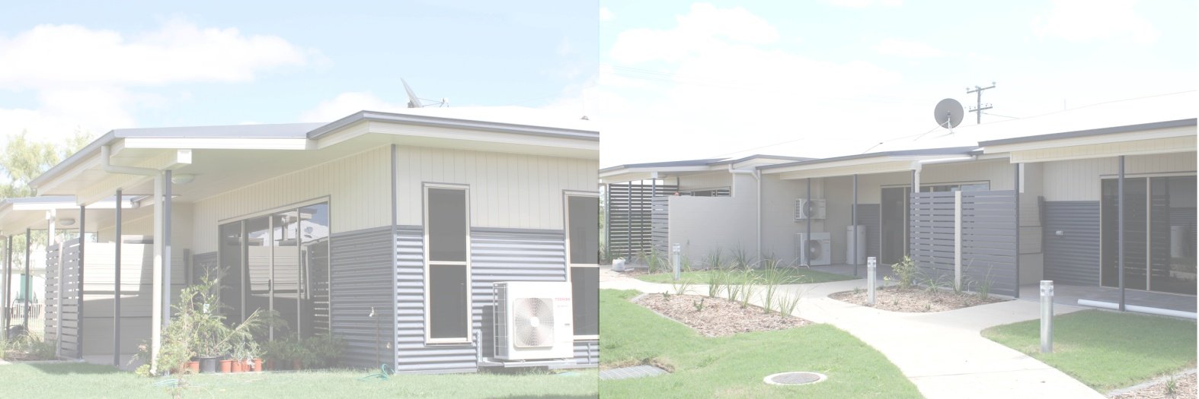
Julia Creek Independent Senior Living Units

APPLICATION FOR RESIDENCY
Please note that completing this application does not guarantee placement.
Name/s:
Postal address:
Residential address:
Phone: |  | Date of birth:
Mobile:
Email:
Are you currently receiving Home Care Package services? | Yes No Unsure
Are you currently receiving Commonwealth Home Support Programme (CHSP) services? | Yes No Unsure
Do you live, or have previously lived in McKinlay Shire? | Yes No Please list dates or number of years:
Do you have family residing in McKinlay Shire? | Yes No Please list dates or number of years:
Do you have an enduring power of attorney? | Yes No In the process of appointing one.  If yes, please attach evidence.
Privacy collection notice: | McKinlay Shire Council is collecting your name, residential address and phone number in accordance with the Local Government Act 2009 in order to process your application. The information will only be accessed by employees and/or Councillors of McKinlay Shire Council for Council business related activities only. Your information will not be given to any other person or agency unless you have given us permission or we are required bylaw.
Signature of Applicant: |  |  | Date:

Please return the completed form to
McKinlay Shire Council 29 Burke St Julia Creek QLD 4823 or via email community@mckinlay.qld.gov.au

