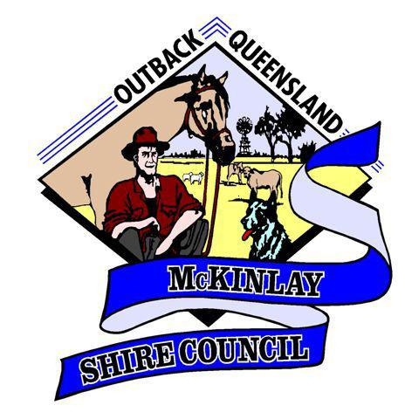
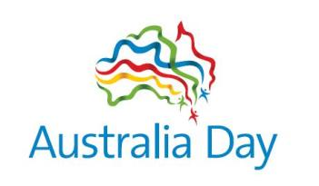
Australia Day 2022
Junior & Senior Sports Award
Nomination Form for the Year of 2021
Criteria
Person who has made a noteworthy record of achievement in Sport
- Junior under the age of 18 on 26th January 2021
- Senior over the age of 18 on 26th January 2021
- Nominee must live within McKinlay Shire and be an Australia Citizen
- Achievements must be within the year of nomination – 2021
- Individuals who have won a Junior Sports Award cannot be nominated for two consecutive years in a row, however, can be nominated in the third year.
- Show significant levels of sporting achievement at local, regional, state, national and international sporting events.
Nomination for:
Junior Sports Award
Senior Sports Award
Details of person being nominated:
First Name |  | Surname:
Address: |  | DOB:
Phone: |  | Email:
Sport/s:

List Achievements (Under appropriate headings)

Local Participation: For this section include details of sports participation and achievements for sports played locally within the McKinlay Shire. (Boarding school students can participate in sport where their school is located). eg aged champion, team captain and competition placing for each sport played.

Shire/School Representation: Nominee must have represented their school or the McKinlay Shire as an individual or within a team at Regional competitions. (Boarding school students can represent their school or the Shire/District where their school is located in). Detail achievements at these Regional competitions during 2020 (include both individual and team performances with event name, date and location).

Regional Representation: Nominee must have represented the Region (Mid West, North West or Boarding School Region) in a team or as an individual at State competitions. Detail achievements at these State competitions during 2020 (include both individual and team performances with event name, date and location).

State Representation: Nominee must have represented Queensland (school or open) in a team or as an individual at National competitions. Detail achievements at these National competitions during 2020 (include both individual and team performances with event name, date and location).

National Representation or Higher: Nominee must have represented Australia (school or open) in a team or as an individual at International competitions. Detail achievements at these International competitions during 2020 (include both individual and team performances with event name, date and location).

Other: Sports performances which do not fit into a regional/state/national competitive selection process can be detailed below (must have occurred during 2020). Please include competition categories, locations, dates and performance levels.
Additional support material may be attached if desired

Other person/s who may be contacted for further information about this person:
First Name: |  | Surname:
Address:
Contact Phone: |  | Email:

To be completed by person submitting this nomination
First Name: |  | Surname:
Address:
Contact Phone: |  | Email:
Signature:

Please send completed form to:
Australia Day Awards
Kalan Lococo – McKinlay Shire Council
PO Box 177
Julia Creek QLD 4823
community@mckinlay.qld.gov.au
All forms must be returned by Friday 26th November, 2021

